

NAME OF THE PROJECT –

**Micro Credit Project**

Submitted by:

**Shubham Mishra**

**ACKNOWLEDGMENT**

For completing this study and preparation of this Data Science, I have received invaluable guidance, encouragement, inspiration and help from a large number of persons and it is my pleasant duty to mention and thank them all.

My first and greatest gratefulness goes to my Mentor **Misses Astha Mishra**, Data Scientist of Filp Robo Technologies without whose constant encouragement, valuable guidance, able supervision and constructive criticism, it would not have been possible for me to complete this work. He was never too busy to spare his valuable time for this work. No words are adequate to express my gratitude to him.

I would like to thanks to all other faculty members and staff members of the Flip Robo Technologies and Data Trained Institute for their suggestions during my Study work.

**Business Problem Framing**

This is a classic Business problem which helps Micro Financing Institutions and other Lending companies reduce Credit risks by recognizing potential Defaulters.

**INTRODUCTION**

**Conceptual Background of the Loan Delinquency**

Before advancement of Data Science, loan lending companies used to risk a high rate of defaulting. Many a times a perfect candidate would display erratic financial and repayment behaviour after being approved for loan. Machine Learning can help lenders predict potential defaulters before approving their candidature using their past data. The candidates’ income, past debt and repayment behaviour can be important metrics for the same.

**Introduction**

A Microfinance Institution (MFI) is an organization that offers financial services to low income populations. MFS becomes very useful when targeting especially the unbanked poor families living in remote areas with not much sources of income. The Microfinance services (MFS) provided by MFI are Group Loans, Agricultural Loans, Individual Business Loans and so on. Many microfinance institutions (MFI), experts and donors are supporting the idea of using mobile financial services (MFS) which they feel are more convenient and efficient, and cost saving, than the traditional high-touch model used since long for the purpose of delivering microfinance services. Though, the MFI industry is primarily focusing on low income families and are very useful in such areas, the implementation of MFS has been uneven with both significant challenges and successes. Today, microfinance is widely accepted as a poverty-reduction tool, representing $70 billion in outstanding loans and a global outreach of 200 million clients. We are working with one such client that is in Telecom Industry. They are a fixed wireless telecommunications network provider. They have launched various products and have developed its business and organization based on the budget operator model, offering better products at Lower Prices to all value conscious customers through a strategy of disruptive innovation that focuses on the subscriber. They understand the importance of communication and how it affects a person’s life, thus, focusing on providing their services and products to low income families and poor customers that can help them in the need of hour. They are collaborating with an MFI to provide micro-credit on mobile balances to be paid back in 5 days. The Consumer is believed to be defaulter if he deviates from the path of paying back the loaned amount within the time duration of 5 days. For the loan amount of 5 (in Indonesian Rupiah), payback amount should be 6 (in Indonesian Rupiah), while, for the loan amount of 10 (in Indonesian Rupiah), the payback amount should be 12 (in Indonesian Rupiah). The sample data is provided to us from our client database. It is hereby given to you for this exercise. In order to improve the selection of customers for the credit, the client wants some predictions that could help them in further investment and improvement in selection of customers.

**Problem Statement**

Build a model which can be used to predict in terms of a probability for each loan transaction, whether the customer will be paying back the loaned amount within 5 days of insurance of loan. In this case, Label ‘1’ indicates that the loan has been payed i.e. Non- defaulter, while, Label ‘0’ indicates that the loan has not been payed i.e. defaulter.

**Methodology**

1. Data Exploration and Cleaning On data exploration, I found that the dataset was imbalanced for the target feature(87.5% for Non-defaulters and 12.5% for Defaulters). Also, I found that the data had some very unrealistic values such as 999860 days which is not possible. Also, there were negative values for variables which must not have one (example: frequency, amount of recharge etc). All these unrealistic values were dropped which caused a data loss of 8% only.
2. Feature Selection Since there were 36 features, many of which I suspected were redundant because of the data duplication. It was imperative to select only most significant of them to make ML models more efficient and cost effective. The method used was 'Univariate Selection' using chi-square test. I selected top 20 features which were highly significant.
3. Data Visualization On visualizing data, there were two important insights I gathered. a. Imbalance of data b. Distribution was not normal
4. Data Normalization Since the data was not normal, I normalized all the features except the target variable which was dichotomous(Values '1' and '0').
5. Oversampling of Minority class Since the data was expensive, I did not want to lose out on data by under sampling the majority class. Instead, I decided to oversample the minority class using SMOTE.
6. Build Models Since it was a supervised classification problem, I built 5 models to evaluate performance of each of them: a. Logistic Regression b. Linear SVM c. Decision Tree d. Random forest e. Gradient Boost Classifier Since the data was imbalanced, accuracy was not the correct performance metric. Instead I focused on other metrics like precision, recall and ROC-AUC curve.

**Analysis of the output of each model**

1. Logistic Regression Among all the models Logistic regression had the best recall values for both the class. Also [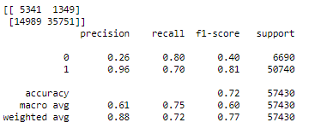](https://user-images.githubusercontent.com/59902500/98761093-8f80b280-2389-11eb-89e0-eb1624703206.png) [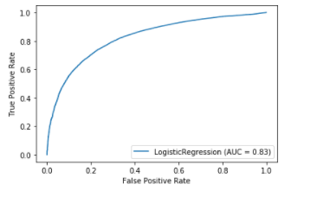](https://user-images.githubusercontent.com/59902500/98761292-fa31ee00-2389-11eb-8a43-533278b794aa.png)
2. Linear SVM [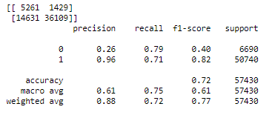](https://user-images.githubusercontent.com/59902500/98761404-38c7a880-238a-11eb-816c-a40583c6d94b.png) [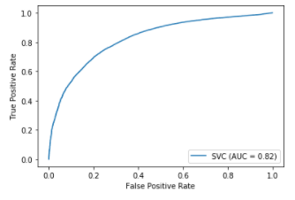](https://user-images.githubusercontent.com/59902500/98761454-4da43c00-238a-11eb-8f95-482ae7da58fe.png)
3. Decision Tree [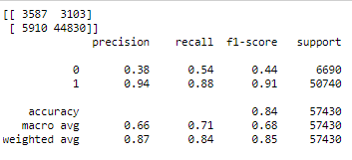](https://user-images.githubusercontent.com/59902500/98761477-5bf25800-238a-11eb-8637-08dcdc86e8f1.png) [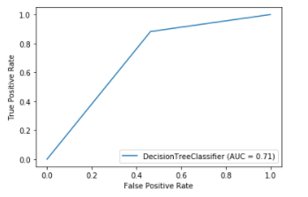](https://user-images.githubusercontent.com/59902500/98761518-70365500-238a-11eb-8971-00ab2bbff599.png)
4. Random Forest [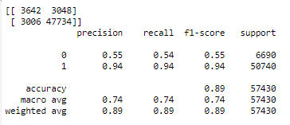](https://user-images.githubusercontent.com/59902500/98761539-847a5200-238a-11eb-95db-657321010cc2.png) [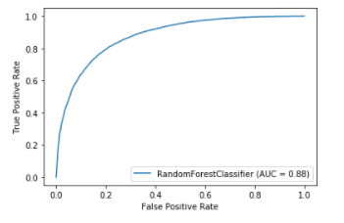](https://user-images.githubusercontent.com/59902500/98761562-952ac800-238a-11eb-9d26-630a02a1f11b.png)
5. Gradient Boosting Classifier [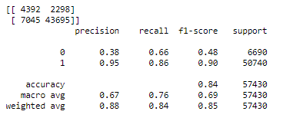](https://user-images.githubusercontent.com/59902500/98761594-a673d480-238a-11eb-909a-462b7e289b90.png) [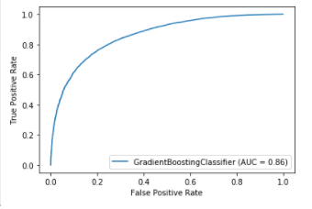](https://user-images.githubusercontent.com/59902500/98761625-b986a480-238a-11eb-9d5b-b83434212fd1.png)